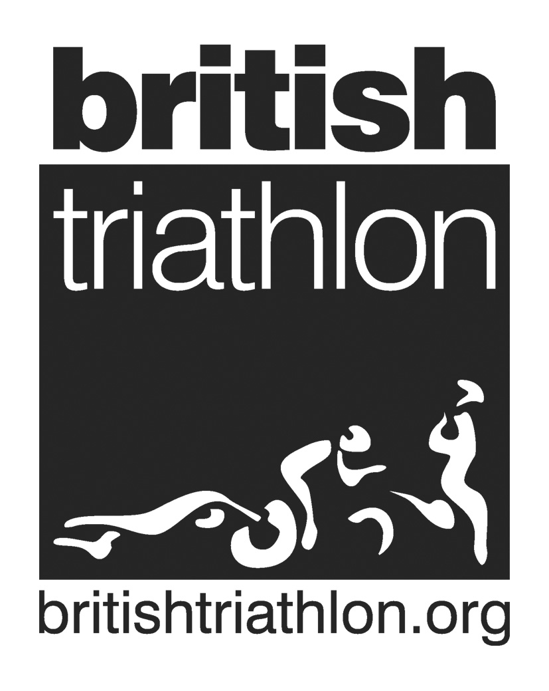
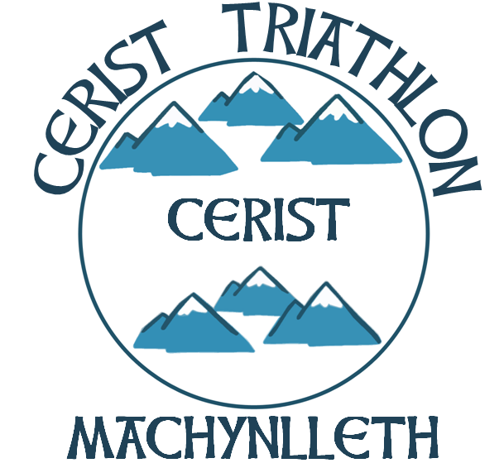
British Triathlon Equity Policy Statement
The British Triathlon Association (BTA) aims to ensure that all people irrespective of their age, gender, disability, race, ethnic origin, creed, colour, social status, religious or sexual orientation, have a genuine and equal opportunity to participate in triathlon at all levels of performance and in all roles.
The BTA aims to ensure that all present and potential members/employees of the Association receive fair and equal treatment through services provided.
It is the aim of the BTA, in its relationship with its present and potential members/employees and in its provision of services not to disadvantage any individual by imposing any conditions or requirements, which cannot be fully justified.
In pursuance of this policy, the BTA may take special measure/positive action for any group which is currently under represented in its membership, representative bodies or workforce taking account of the Race Relations Act (1976), Equal Pay Act (1970), Sex Discrimination Acts (1975, 1986), Disability Discrimination Act (1995).
In pursuance of this policy, the BTA reserves the right to discipline any members/employers of the BTA who practice any forms of discrimination on the grounds of age, gender, disability, race, ethnic origin, creed, colour, social status, religious or sexual orientation. The BTA will maintain demographic records of its membership/employees.
The BTA will monitor and evaluate the impact of this policy, and focus its services accordingly.

Club Equity Policy Statement

CLUB NAME…………Cerist Triathlon……………………………………………….

This club is committed to ensuring that equity is incorporated across all aspects of its development. In doing so it acknowledges and adopts the following Sport England definition of sports equity:

Sports equity is about fairness in sport, equality of access, recognising inequalities and taking steps to address them. It is about changing the culture and structure of sport to ensure it becomes equally accessible to everyone in society.

The club respects the rights, dignity and worth of every person and will treat everyone equally within the context of their sport, regardless of age, ability, gender, race, ethnicity, religious belief, sexuality or social/economic status.

The club is committed to everyone having the right to enjoy their sport in an environment free from threat of intimidation, harassment and abuse.

All club members have a responsibility to oppose discriminatory behaviour and promote equality of opportunity.

The club will deal with any incidence of discriminatory behaviour seriously, according to club disciplinary procedures

