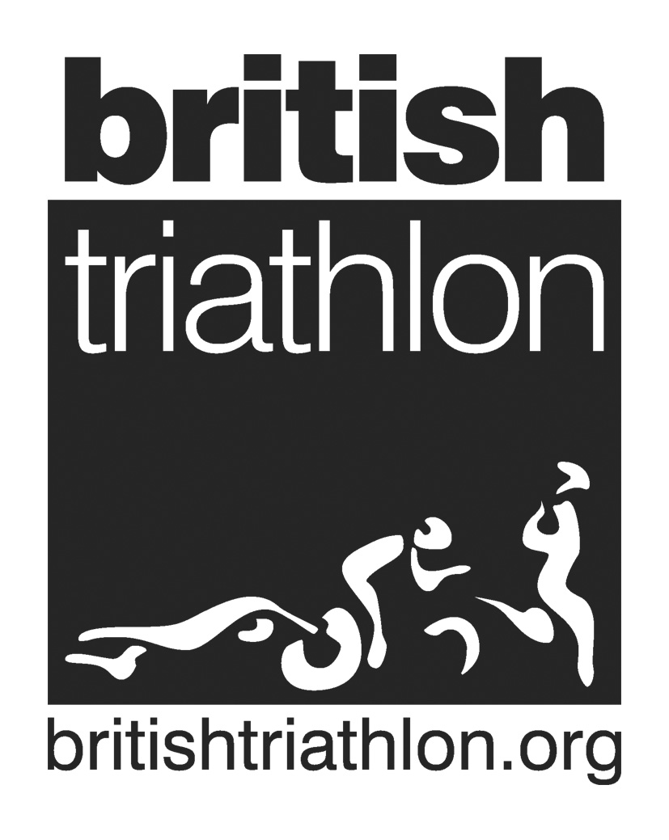
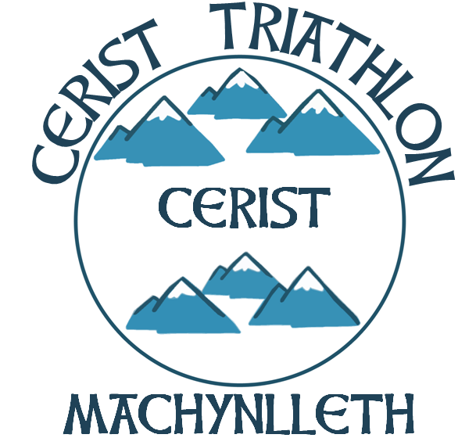
Club Rules

These rules may be amended from time to time at the discretion of the committee. All changes will be publicised to members

Serious disregard or breaches of these rules reported to the committee may result in the offending member being expelled from the club. The Club’s disciplinary procedure will be applied.

GENERAL
- Members agree not to bring the Club into disrepute
- Members agree upon and have signed a Code of Conduct
- Members must abide by the rules and articles of British Triathlon

TRAINING (CLUB ORGANISED ACTIVITIES)
A. SWIMMING
1) The local swimming pool rules must be adhered to
2) Members must not enter water until appropriate number of lifeguards is in place for all swim sessions
3) In open water members must make themselves aware of all specific dangers relating to the chosen location. Members must take their own appropriate safety precautions, and ensure reasonable safety cover is in place (see Open Water Guidelines)
4) Members must not swim in prohibited areas

B. CYCLING
1) Helmets must be worn
2) Cyclists must obey the Highway Code
3) Cyclists must be courteous to other road users.

C) RUNNING
1) Members must have due regard for pedestrians and other legitimate users of foot paths, roads and bridleways, and any other users of the land especially farmers

COMPETITION
1) Members must obey all rules relating to the event they are competing in and compete in a sportsman-like manner

CLUB PROMOTIONS
1) Members are welcome to compete in events organised by the Club but must provide a replacement marshal.

MEDICAL INFORMATION
1) Members are responsible for advising the coach or race organiser of any significant medical conditions and emergency contact information

